1. **The Evolution of Vernalisation in Flowering Plants**

In flowering plants, sensing surrounding environmental conditions and regulating flowering time to tightly correspond with the changing environment is the key to maximising reproduction potential. Flowering too early can result in damage to delicate reproductive organs during unseasonal cold ‘snaps’, while flowering too late could result in the plant missing out on favourable spring time growing conditions. Crop planting schedules are planned to specifically exploit a plant’s mechanisms to respond to environmental cues, such as vernalisation, to maximise yield. While individual plant species respond differently at the genetic level to their changing environment, the predominant mechanism used by plants is to regulate their time to transition from vegetative to reproductive growth.

1. **The Vernalisation Response**

Vernalisation is characterised by a prolonged exposure (a period of greater than ten days) to low, but non-freezing temperatures. Vernalisation (from the Latin *vernum*, meaning *spring*), and its effect on harvest time and crop yield has been a central plant biology research focus for over 150 years (Klippart 1857; Gassner 1918). The temperature at which the vernalisation response is triggered differs widely between individual crop species, and even between cultivars of the same species (see Table 1). It is theorised that the threshold temperature that triggers a vernalisation response can be calculated by examining the rate of growth under a range of temperatures, extrapolating the curve, then selecting a temperature a few degrees above the inferred basal temperature (Angus et al. 1980). Sugar beet (*Beta vulgaris*), and carrot (*Daucus carota*), must be exposed to vernalisation before these plants are able to transition to flowering (an *absolute* vernalisation response) (Dijk et al. 1997; Alessandro et al. 2013). However, in wild populations of these two species, plants grown in warmer temperatures require a shorter period of vernalisation to trigger flowering. In species where vernalisation is not an essential requirement for flowering transition (a *facultative* vernalisation response), such as *Arabisopsis* *thaliana* (*Arabidopsis*; Burn et al. 1993; Bastow et al. 2004), narrow leaf lupin (*Lupinus Augustifolius*; Landers 1995), and winter wheat (*Triticum aestivum*) and barley (*Hordeum vulgare*; Trevaskis et al. 2006; Oliver et al. 2009), vernalised plants flower sooner than plants that have not been exposed to a vernalisation treatment (Sheldon et al. 2000). The genetic pathways for the vernalisation response in plants are family-specific: not just between dicotyledonous (dicots) and monocotyledonous (monocots) species, but also within different dicot species (Reeves et al. 2007). Despite these differences, the gene pathways in vernalisation responsive plants are epigenetic in nature, for example; a vernalisation sensitive plant will express a distinct phenotype once vernalised, however these epigenetic-based phenotypic differences are reset in the following generation(s).

In *Arabidopsis* and other dicots, the shoot tip is located at the crown of the plant and contains the shoot apical meristem (SAM). The SAM itself is composed of a collection of pluripotent stem cells that slowly divide and differentiate into the various progenitor cells necessary for vegetative tissue growth (Meyerowitz 1997; Fletcher 2002). In *Poa pratensis* (Kentucky Bluegrass), and other monocots, the location of this cell population differs being present in the basal meristem at the bottom of the plant, just above the soil line (Etter 1951). Regardless of location, after floral induction, the types of progenitor cell that the pluripotent meristem cells produce changes from those required for vegetative development to progeny cells necessary for the generation of tissue and organ structures essential for flowering (**Ref**). In 1962, Wellensiek showed that in a number of plant species containing a SAM, moving vernalised shoot material to non-vernalised root stock resulted in the generation of a plant expressing a vernalised phenotype (Wellensiek 1962). Similarly, moving non-vernalised shoot stock to vernalised root stock resulted in the production of plants expressing a non-vernalised phenotype. Together, Wellensiek’s early observations indicated that while the tissues and/or organs of some plants were vernalisation responsive, the most crucial location for a phenotypic response to vernalisation was the shoot tip, a structure that houses the developmentally important SAM in the studied dicot species. Presumably, a similar effect would be observed in monocots, where grafting a basal meristem of a vernalised plant onto a non-vernalised root stock would result in the expression of a vernalisation phenotype, and vice versa. However, the literature is not clear in this regard.

***2.1 Vernalisation in* Arabidopsis thaliana**

In *Arabidopsis*, the MADS-box transcription factor FLOWERING LOCUS C (FLC), is a key mediator in the transition from vegetative to reproductive phase change (Riechmann & Meyerowitz 1997). Prior to vernalisation, *FLC* expression is promoted by FRIGIDA (FRI), FRIGIDA-LIKE1(FRL1) and FRIGIDA-LIKE2 (FRL2; Werner et al. 2005). FLC acts as a transcription repressor, specifically repressing the expression of *FLOWERING LOCUS T* (*FT*; Sheldon et al. 2000). In the *Arabidopsis* ecotype, Columbia-0 (Col-0), and upon *FLC* expression, VERNALISATION 2 (VRN2) complexes with CURLY LEAF (CLF), SWINGER (SWN) and FERTILIZATION-INDEPENDENT ENDOSPERM (FIE) to form the VERNALISATION 2 (VRN2)/Plant Homeo domain Polycomb Repression Complex 2 (VRN2/PHD-PRC2; Köhler & Villar 2008). The VRN2/PHD-PRC2 complex constitutively binds to the *FLC* locus to maintain *FLC* in an open confirmation. This is primarily achieved via H3 acetylation, loosening the nucleosome-*FLC* interaction and thus allowing transcriptional machinery access to *FLC*, to promote *FLC* expression (De Lucia et al. 2008).

When *Arabidopsis* Col-0 is exposed to non-freezing cold, *VERNALISATION INSENSITIVE 3* (*VIN3*), *VERNALISATION 5/VIN3-LIKE* (*VEL1*) and *VERNALISATION 5* (*VRN5*) expression is triggered. VIN3, VEL1 and VRN5 bind to the VRN2/PHD-PCR2 complex to promote histone H3 deacetylation, and *VRN2*-directed trimethylation of H3K9 and H3K27 at the *FLC* locus (Sung & Amasino 2004). Furthermore, the *FLC* promoter region is simultaneously demethylated at H3K4 by the VIN3/VEL3/VRN5-VRN2/PHD-PCR2 complex (Finnegan et al. 2005). Together, these chromatin modifications, closes the open conformation of the *FLC* locus, blocking transcriptional machinery from accessing *FLC*, thereby repressing *FLC* expression (Finnegan & Dennis 2007). This epigenetic-based repression of *FLC* expression is stable and irreversible, ensuring that the transition of vernalised Col-0 from vegetative to reproductive development is permanent (Levy et al. 2002).

When the *FLC* locus adopts transcriptionally inactive confirmation, the expression of *FT*, the FT homolog *TWIN SISTER OF FT* (*TSF*), and *SUPPRESSOR OF OVEREXPRESSION OF CONSTANS1* (*SOC1*) is promoted. The FT protein travels through the phloem to the SAM (Corbesier et al. 2007), and in the SAM, FT triggers floral induction by promoting the transition of meristem cells to a reproductive fate via promoting the expression of *LEAFY* (*LFY*) and *APETALA1* (*AP1*), two primary promoters of floral apical meristem development (Amasino 2004). Together, LFY and AP1 promote the pluripotent cells of the SAM to divide and adopt reproductive fates, and this eventually leads to the formation of flowering bodies (Ref).

There are five additional FLC homologs encoded by *Arabidopsis*, and all five are alsoregulated by vernalisation. Like *FLC*, the expression of *MADS AFFECTING FLOWERING1* (*MAF1*),through to *MAF4,* are all downregulated by vernalisation. However, the expression of *MAF5* is upregulated by vernalisation (Ratcliffe et al. 2003). Furthermore, it has been demonstrated that different isoforms of the *MAF2* transcript are expressed at different temperatures, with *maf2* mutants showing an inability to repress flowering at low temperatures (Airoldi et al. 2015). This indicates that although FLC is the central regulator of flowering in *Arabidopsis*, and the main target of vernalisation-directed regulation, FLC is not the sole regulator of vernalisation-induced flowering in *Arabidopsis*. Modifications to genes upstream of FLC that regulate *FLC* expression are also important contributors to the regulation of flowering in *Arabidopsis*. Natural variations in *FRI* expression in individual *Arabidopsis* ecotypes that result in low FRI levels have been shown to decrease the time to flowering, further indicating that FRI is a promoter of *FLC* expression (Werner et al. 2005). Similarly, loss of function *vin3* mutants have lost the ability to detect cold, with *vin3* plants failing to respond to vernalisation (Sung & Amasino 2004). *– I am not 100% sure of this paragraph, it just comes across as a series of individual facts, no real linkage to one another or to the remainder of this section – this needs work?*

***2.2 Vernalisation in Legumes***

There are multiple members of the *Fabaceae* (legume) genera that respond to vernalisation. *Medicago truncatula* (*Medicago*) encodes three *FT-like* gene classes, including *FTa*, *FTb* and *FTc.*  These three *FT-like* gene classes are conserved across the *Fabaceae*, but curiously to date, have not been reported in any other angiosperm (Hecht et al. 2011). Medicago encodes five *FT-like* genes , including *MtFTa1*, *MtFTa2*, *MtFTb1*, *MtFTb2* and *MtFTc* (Laurie et al. 2011), and of these, *MtFTa1* is over-expressed in the *Medicago* spring mutant (Putterill et al. 2013). In wild-type *Medicago* however, *MtFTa1* overexpression is only observed after exposure to vernalisation (Jaudal et al. 2013). *Medicago* species also appear to lack orthologs of *Arabidopsis* FLC and MAF (Hecht et al. 2005), but do encode for a FRI-like (*Mt*FRI-like) protein. When the *MtFRI-like* coding sequence was expressed in *Arabidopsis* Col-0, flowering time was delayed. This strongly suggests that *Mt*FRI-like mediates a functionally similar role to *At*FRI: the promotion of *FLC* expression (Chao et al. 2013).

In addition to *Medicago*, the vernalisation response of pea (*Pisum*) has been studied for some time (Reid & Murfet 1975). More recently, research in the *Lupinus* genus, namely study of *L. albus*, *L. augustifolius* and *L. luteus*, has revealed a vernalisation response similar to that of *Arabidopsis* (Gladstones & Hill 1969; Landers 1995). In both *Pisum* and *Lupinus*, decreased time to flowering is inversely proportional to the time that seedlings are vernalised. While the exact molecular mechanisms mediating this phenotypic response has not been determined in these genera, it could be surmised that orthologs of the *Medicago* FT-like family could also be mediating a similar and central role. Even in the absence of MADS-box orthologs to FLC, and to MAF1through to MAF5, proteins that critical to vernalisation response and flowering time in *Arabidopsis*, *Fabaceae* are still able to response to vernalisation environmental cues, as evidenced by the over-expression of *MtFTa1* in the *Medicago* spring mutant plant line and the homologous functional role mediated by *MtFRI-like* when expressed in *Arabidopsis*. However, the exact mechanistic role directed by these vernalisation response regulators in legumes remains to be determined.

***2.3 Vernalisation in Texas Bluebell***

Texas Bluebell (*Eustoma* spp.) is an ornamental flowering plant native to the southern United States, Central America and the northern regions of South America (**Refs?**). *Eustoma* have a similar vernalisation response to *Arabidopsis* and *L. augustifolius*, where the time to flowering is inversely proportional to the period of cold exposure (Pergola 1992). *Eustoma* *grandiflorum* encodes homologs to *Arabidopsis* FLC, FT and SOC1 (EgFLCL, EgFTL and EgSOC1L respectively). EgFTL and EgSOC1L appear to be functional homologs of their *Arabidopsis* counterparts and are lowly expressed until restoration of an inductive photoperiod post vernalisation. At this time, the expression of *EgFTL* and *EgSOC1L* increases. However, *EgFLCL* appears to be lowly expressed during vegetative growth and only increases with the onset of vernalisation, the opposite expression profile to that widely reported for *Arabidopsis* *FLC* (Nakano et al. 2011). Alternatively, this may indicate that EgFLCL is more closely functionally related to *Arabidopsis* MAF5, than to the other MADS-box proteins involved in vernalisation response, such as FLC and MAF2-5 (Ratcliffe et al. 2003). Therefore, rather than directly repressing the expression of *EgFTL*, EgFLCL may restrict the expression of a target gene which is itself a repressor of *EgFTL* expression in *Eustoma*.

***2.4 Vernalisation in Sugar beet***

Sugar Beet (*Beta vulgaris* ssp. *Vulgaris*) is extensively cultivated in northern hemisphere countries for its large, sucrose rich root organ (**Ref**). Photothermal induction (that is; exposure to vernalisation conditions followed by increased day length) is necessary for flowering in sugar beet (Owen et al. 1940). Because of an absolute vernalisation requirement for flowering, breeders have selected phenotypes that maintain the vegetative and root growth state in order to maximise root yield (**Ref**). Recent studies have characterised the molecular mechanisms underpinning the vernalisation response in beet to demonstrate that they are distinct to those of other species (Pin et al. 2012). Two paralogous *FT* genes, *BvFT1* and *BvFT2*, central to the regulation of flowering, are controlled by BOLTING TIME CONTROL1 (*Bv*BTC1; the *B*. *vulgaris* ortholog of *At*FLC), and inturn, *Bv*FT1 is responsible for regulating *BvFT2* expression(Pin et al. 2010). The requirement for two *FT-like* genes for control of flowering time in *B*. *vulgaris* is distinct to the requirement of a single FT to control flowering in *Arabidopsis*. In biannual wild-type sugar beet, ecotypes that naturally occur further north contain a greater composition of a recessive allele of *Bvbtc1*, and display an absolute vernalisation requirement phenotype. As the latitude increases and the location becomes closer to the warmer climate of the Mediterranean, the requirement for vernalisation for the promotion of flowering diminishes, and furthermore, the dominant *BvBTC1* allele predominates in the naturally occurring varieties of this region (Dijk et al. 1997). While the vernalisation pathway in *B. vulgaris* is distinct from *Arabidopsis*, it also containsa number of homologous pathways, including the photoperiod pathway (Chia et al. 2008), and the autonomous pathway (Abou-Elwafa et al. 2011). However, these pathways require further experimental characterisation.

***2.5 Vernalisation in Cereals***

Monocots, such as bread wheat (Triticum aestivum), barley (Hordeum vulgare) and Brachypodium distachyon (a model monocot) use a vernalisation pathway that is distinct to that of Arabidopsis and other dicot species. While there are a number of genetic mechanisms conserved between monocots and dicots, the most notable difference is the absence of a known Arabidopsis FLC homolog in cereals. Instead, the interplay between VRN1 (a MADS-box transcription factor), VRN2 (the cereal VRN2 is distinct from the AtVRN2; Yan et al. 2004), and VRN3 (a homolog of AtFT; Trevaskis et al. 2007), regulates the response to vernalisation.

In cereals, VRN1 serves two purposes; i) a regulator of VRN2 expression, and; ii) a key meristem identity gene (Trevaskis et al. 2007). Recessive alleles of VRN1 in winter wheats (vrn1-A1|B1|D1) require vernalisation for expression induction otherwise the winter wheat varieties express a late flowering phenotype. Spring wheat varieties express dominant VRN1 alleles, and unsurprisingly are naturally early flowering (Trevaskis et al. 2003). During vernalisation of winter barley, H3K27 demethylation and H3K4 tri-methylation occurs at the HvVRN1 locus. This modifies the shape of the local chromatin for the chromatin to adopt an open conformational, allowing transcriptional machinery access to the VRN1 template, and hence, promotion of VRN1 expression (Oliver et al. 2009). Similar to the chromatin modifications at the FLC locus in Arabidopsis, this epigenetic change is stable. However in winter barley, and in direct contrast to AtFLC chromatin modifications, this conformational change permits, rather than restricts, transcriptional machinery access to the HvVRN1 locus.

Similar to the *Arabidopsis* flowering pathway where FLC represses FT expression, HvVRN2 represses the expression of HvVRN3 in barely (Ream et al. 2014). Prior to vernalisation of winter cereals, the floral repressor ODDSOC2 (OS2) is also present at high levels, and functions together with HvVRN2 to maintain the cereal in a vegetative growth state (Greenup et al. 2010). After vernalisation, increased HvVRN1 represses HvVRN2 expression. Low HvVRN2 levels allows for the expression of HvVRN3, and increased HvVRN3 levels ultimately triggers the transition to flowering in winter barley (Trevaskis et al. 2006). High HvVRN1 levels post exposure to vernalisation also stably inhibits OS2 expression. Reduced OS2 levels promotes the expression of FPF1, which in turn promotes the transition to a flowering state. This mechanism of VRN1 repressing VRN2 expression is readily observed in spring cereals, as VRN1 is expressed in these spring varieties regardless of their exposure (or there lack of) to vernalisation.

VRN3 is the downstream target of VRN2. Following VRN1 repression of VRN2 expression (that is; after vernalisation of winter cereals), decreased VRN2 allows for the expression of VRN3, the homolog of Arabidopsis FT. VRN3 subsequently interacts with VRN1, which in addition to acting as a repressor of VRN2 expression, VRN1 is also a promoter of meristem identity and developmental transition to flowering. It is only at this point that the cereal can transition from its state of vegetative development to a state of reproductive growth. Taken together, the lack of an FLC homolog, in addition to the dual functionality of VRN1, both as a meristem identity factor and as a represser of VRN2 expression, demonstrates a genetic divergence of the cereals from dicot plants in regards to their response to vernalisation.

***2.6 Vernalisation in the Asteraceae***

While much of the historic research attention has focused on the vernalisation response of major crop species and the genetic model plant *Arabidopsis*, current research regarding the vernalisation response in safflower, and indeed, other members of the *Asteraceae* family (one of the largest and most diverse flowering plant families) is scarce. Early research in lettuce (*Lactuca sativa*) reported germinated seed that had been vernalised prior to planting responded by progressing to the bolting stage up to four weeks earlier than unvernalised seed (Figure 2; Gray 1942; Warne 1947; Rappapport et al. 1956). A later study indicated that lettuce indeed responded to vernalisation and extending day length cues. However, this research also showed that lettuce was still able to transition to flowering in the absence of these environmental cues (Waycott 1995). Although this research was restricted to studying the physiological response of lettuce to vernalisation they strongly indicated a *facultative* vernalisation response in lettuce, similar to *Arabidopsis*.

Chicory (*Cichorium intybus*) is an *Asteraceae* with an absolute vernalisation requirement. *CiFL1*, a MADS-box transcription factor with significant sequence homology to *Arabidopsis FLC*, is expressed during vegetative growth. Similar to the expression profile of *AtFLC* when *Arabidopsis* is exposed to vernalisation conditions, the expression of *CiFL1* is repressed upon vernalisation of chicory (Périlleux et al. 2013). Furthermore, when *CiFL1* was over-expressed in *Arabidopsis*, the resulting *Arabidopsis* transformant lines showed a significant delay in the onset of flowering, regardless of vernalisation exposure. This strongly indicates similar molecular functionality of *Ci*FL1 and *At*FLC in the *Arabidopsis* flowering pathway. However, when vernalised chicory plants are returned to warmer growing conditions, *CiFL1* expression again increases to reveal that vernalisation-mediated repression of *CiFL1* expression is transient, and not stable like the repression of *FLC* expression in vernalised *Arabidopsis*.

Early studies in safflower revealed that in some varieties there is a relationship between photoperiod, vernalisation and a decrease in the time to flowering (Zimmerman 1973). While a FLC homolog may be present in many *Asteraceae* (Reeves et al. 2007), based on what is seen in *Eustoma*, there may be no functional homolog of FLC in this genus, or if homology does exist between an *Asteraceae* FLC and the well characterised *Arabidopsis* FLC, it will be purely at the nucleotide level. Limited *Asteraceae* genetic resource availability makes the molecular characterisation of vernalisation within this genus challenging. As further resources become available, and are more thoroughly annotated, the molecular mechanisms by which vernalisation, as well as other factors, affect flowering time in safflower and other *Asteraceae* will become better understood.

1. **Phylogenetic Analysis of Vernalisation Responsive Species**

Approximately 34 million years ago, the geological transition from the tropical Eocene age to the modern, temperate Oligocene age occurred (Silva & Jenkins 1993; Speelman et al. 2009). This change resulted in a drop in the minimum mean winter temperature after the Eocene/Oligocene (E/O) boundary (Ivany et al. 2000). Using marine temperatures as a proxy for land temperatures, this drop resulted in a ‘mass’ extinction event. Species that could not adapt to the cooler, temperate climate perished, while species that could respond to the extended periods of winter cold survived. These species have since diversified

Out of all of the flowering plant species investigated, and within the dicots, only the *Fabaceae* lack an *FLC* homolog. The closest family to the *Fabaceae* is the *Brassicales* <*difference in evolutionary time*>, a family that includes the genetic model species *Arabidopsis*.The Rosids have possibly diverged from the other flowering plant clades in terms of the way that vernalisation influences *FLC* expression. The *Fabaceae* family appear to have diverged even further, shedding *FLC* during their diversification, while still maintaining a vernalisation response. The monocots are the furthest removed from the other investigated families of flower plant <*difference in evolutionary time*>, which may in part, explain not only the physical and physiological differences between monocots and dicots in their response to vernalisation, but also the specificities in the genetic mechanisms that underpin these differences.

Within the *Asterids*, the differences between the genetic mechanisms directing the vernalisation responses of the *Caryphyllales* and the *Gentianales*,could at least be partially explained by the fact that the *Caryphyllales* represent an primitive lineage of flowering plants (Wang 2010). The *Gentianales*, and the *Asterales* on the other hand, have diverged from a common ancestor. Of future interest will be the determination if the *Asterales*, another lineage of ancient flowering plant, share similar genetic mechanisms to those associated with the vernalisation responses of the *Caryphyllales* and the *Gentianales*.

Eustoma and Asteraceae reasonably close, hence both containing FLC? Make an inference that this is the case. Anything on sunflower/lettuce and FLC?

Which is older? Eustoma or Asteraceae?

<http://tolweb.org/Gentianales/20724>

<http://tolweb.org/Asteraceae/20780>

1. **The rise, and rise, of ’Omic’ sequencing**

In the last 15 years, Next Generation Sequencing (NGS) has greatly expanded the quantity and quality of the genetic information currently available to the scientific research community as a whole. Today, the availability of genomic (DNA), transcriptomic (RNA) and proteomic (protein) sequence based information is at levels never seen before, and furthermore; generation of such data requires significantly less time and is achieved at a fraction of the cost (Wetterstrand 2014). This has allowed the generation of ‘omes’ at an almost routine frequency. The overarching expectation of the scientific community was that this expansion in data generation capability would quickly allow for more detailed understanding of even the most complex of genetic pathways. However, the opposite has been observed. Mining of these data sets has repeatedly produced even further questions as to the multilayered complexity of the mechanisms that underlay even some of the most well understood genetic pathways.

1. **Conclusions**

In numerous plant species, the presence, and or there absence of a vernalisation response has been well documented for quite some time. While the phenotypic response to vernalisation is consistent between different facultative or absolute vernalisation species, the underlying genetic mechanisms that underpin these responses differ substantially. During vernalisation in *Arabidopsis*, *FLC* expression is repressed via epigenetic modification of the *FLC* locus. Histone methylation, and the associated condensing of the chromatin surrounding *FLC*, blocks transcriptional machinery access to the locus, and thus repressing *FLC* expression and subsequent promotion of the expression of *FT* and other genes downstream of FLC in the *Arabidopsis* flowering pathway. In barely however, repression of *VRN2* by VRN1 promotes the expression of the *FT* homolog, *VRN3*, allowing the transition of barley to flowering. Sugar beet has a different mechanism again, encoding two FT homologs, *Bv*FT1 and *Bv*FT2, with opposing functional roles in the sugar beet flowering pathway. It has also been shown that while both *Eustoma* and *Arabidopsis* express *FLC* homologs, *Eg*FLCL has the opposite effect on Eg*FTL* expression in *Eustoma* than the repressive nature of *At*FLC on *AtFT* expression in *Arabidopsis*. Together, this data begs the question: is the role of *FT* expression repression by FLC unique to members of the *Brassicaceae* family?

In the plant varieties discussed above that are vernalisation responsive, *FT* (or its variants), is expressed in true leaves, with the expression of the downstream targets of FT modulated in the shoot apical meristem. While the downstream effects of extended cold exposure can be observed in the phenotypic vernalisation response, the molecular mechanisms of how plants detect cold in the first instance is still poorly understood, and remain difficult to elucidate. It was hoped that with the rapid expansion of gene expression analysis via NGS, the molecular basis of such mechanisms would be uncovered, at least partially. However, to date, this has not proven to be the case. While NGS technology has provided amazing insight into many fundamental questions, such an approach has failed to shed any additional light on the molecular mechanisms that plants use to detect exposure to cold. Perhaps there is another factor involved. In all of the examples of vernalisation examined, and while the gene affected by vernalisation has been repeatedly demonstrated, the specific mechanism that causes this effect remains to be identified in every instance. Helliwell and colleagues (2015) postulated that physical changes brought on by vernalisation conditions modulates the way DNA behaves in cells, essentially removing the natural elasticity of DNA. Therefore, if a locus adopts an open confirmation during the cold, it will remain open, allowing prolonged access to the local site for the associated genetic machinery. This may be another avenue of investigation to characterise the physical modifications, at the molecular level, that vernalisation has on all vernalisation responsive plants, not just *Arabidopsis*.

**Table 1.** Approximate ages of investigated plant families. (Stevens 2001). Approximate age of family has been derived from the references in the age section of site where possible – *fix this up please?*

|  |  |  |
| --- | --- | --- |
| **Family** | **Age (million**  **years old)** | **Location** |
| Asterales |  | http://www.mobot.org/MOBOT/research/APweb/orders/ asteralesweb.htm#Asterales |
| Brassicales |  | http://www.mobot.org/MOBOT/research/APweb/orders/ brassicalesweb.htm#Brassicales |
| Caryophyllales |  | http://www.mobot.org/MOBOT/research/APweb/orders/ caryophyllalesweb.htm#Caryophyllales |
| Fabales |  | http://www.mobot.org/MOBOT/research/APweb/orders/ fabalesweb.htm#Fabales |
| Gentianales |  | http://www.mobot.org/MOBOT/research/APweb/orders/ gentianalesweb.htm#Gentianales |
| Poales |  | http://www.mobot.org/MOBOT/research/APweb/orders/ poalesweb.htm#Poales |

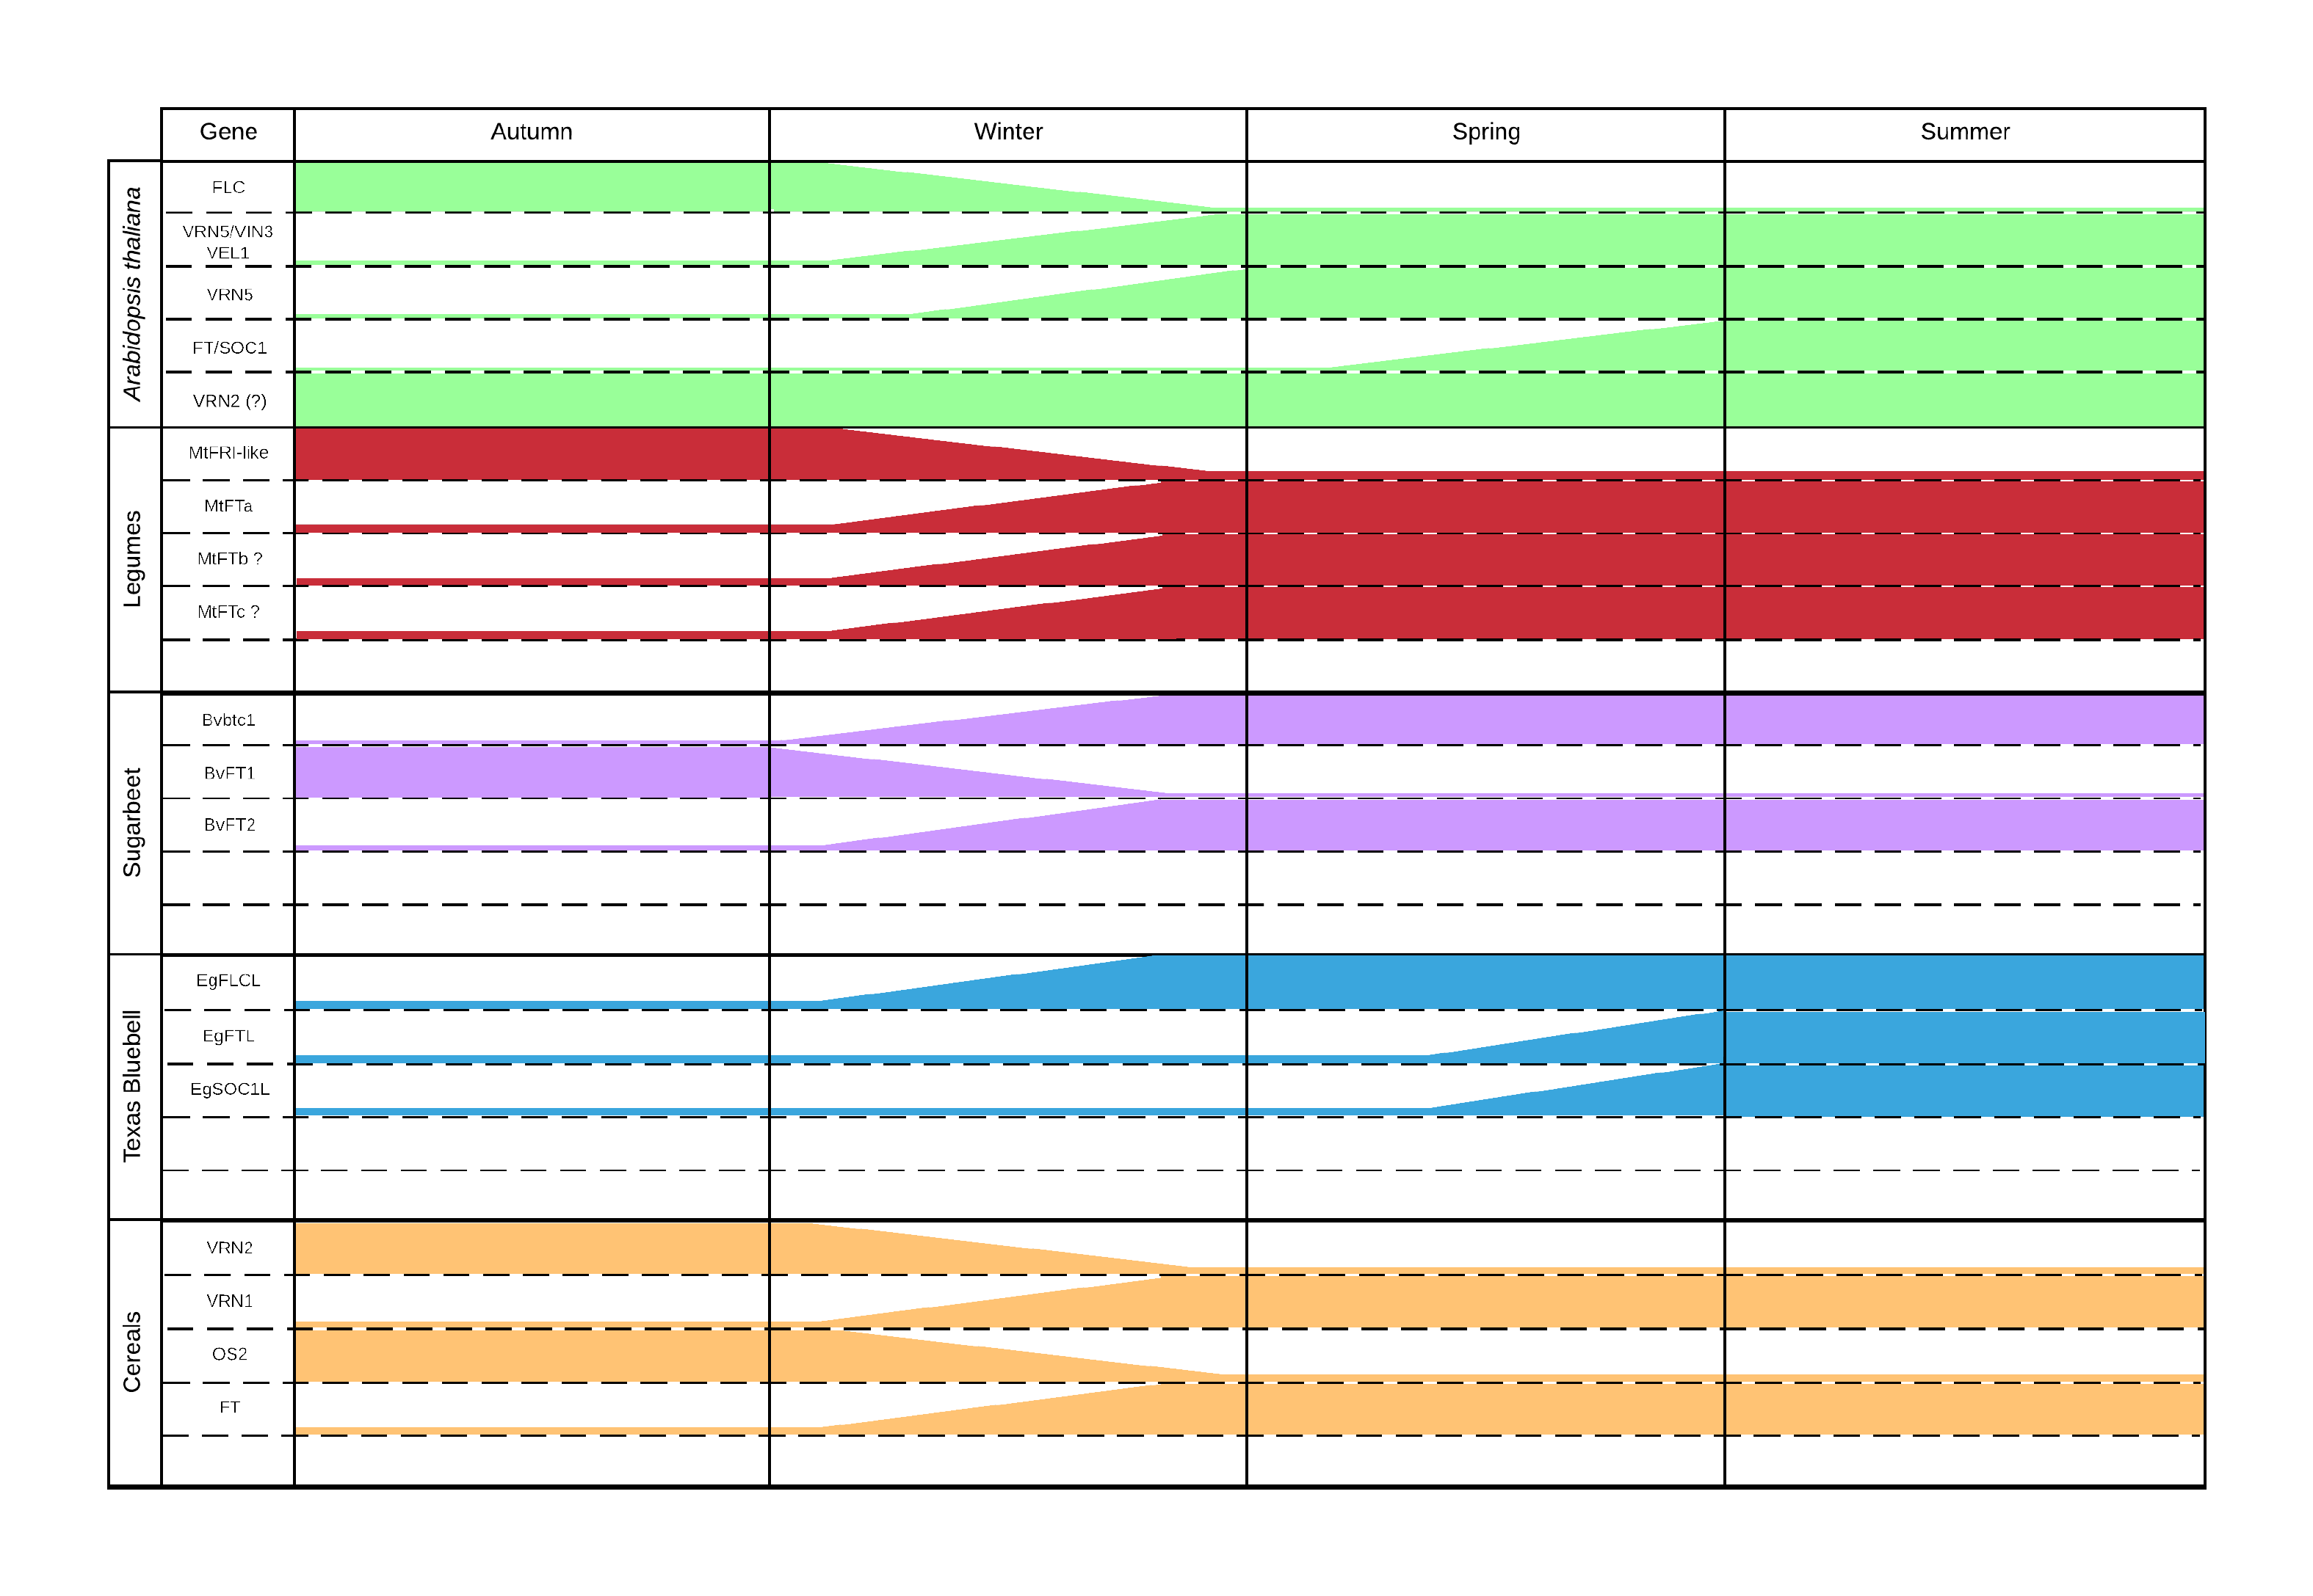

**Figure 1.** *The expression of flowering time genes in different plant species after exposure to vernalisation*.

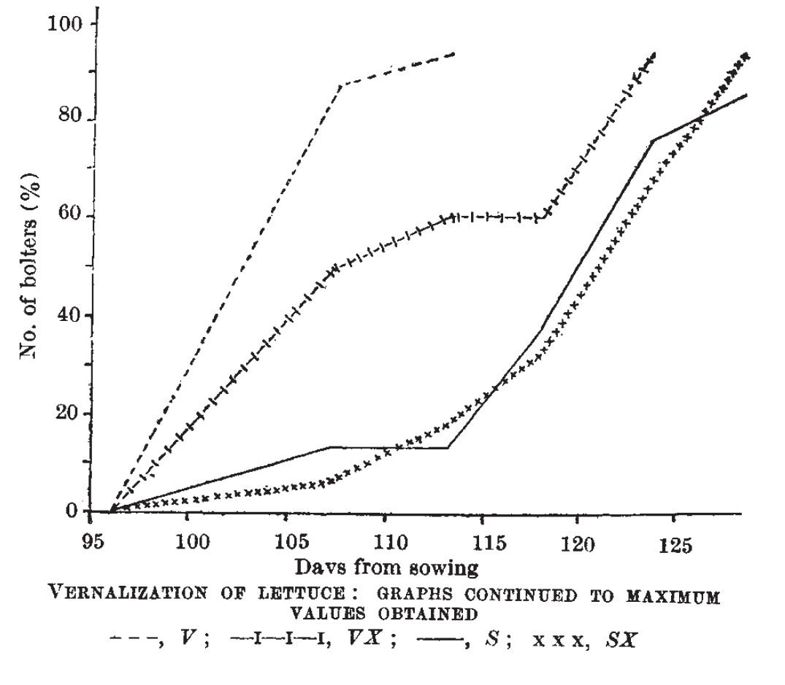

**Figure 2.** *The vernalisation response of lettuce (*L. sativa*)*. Figure taken from Wayne (1947). V, vernalised lettuce; VX, what does this stand for?; S, what does this stand for?, and; SX, what does this stand for?.

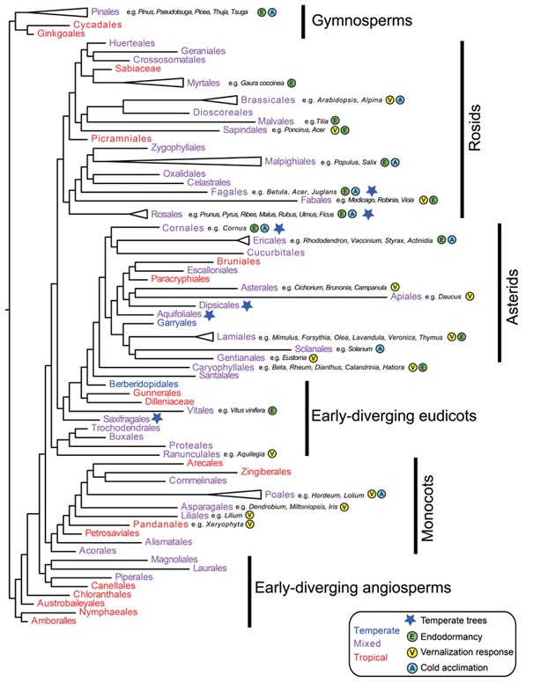

**Figure 3.** *Phylogenetic analysis of the different seed producing plant families*. The individual members of the represented families examined in this review have been indicated with a grey shaded box around the family name and attributes. Image adapted from Preston and Sandve (2013), and the approximate ages of each plant families is taken from Stevens (2001).